
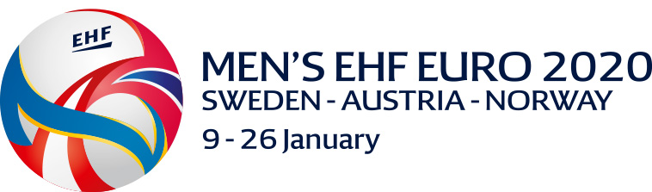
Men’s EHF EURO 2020 – Final Tournament in Sweden-Austria-Norway
PLAYERS INFORMATION
Nr. | Family name | First name | Club | Date of birth | Height | Weight | Int. matches
 | JANDRIĆ | Todor | Metaloplastika | 02.06.1998. | 199 cm | 105 kg | 0
 | PUŠICA | Miljan | Minden (GER) | 30.06.1991. | 200 cm | 106 kg | 42
 | VUJIĆ | Stefan | Dinamo Bukuresti (ROU) | 06.07.1991. | 192 cm | 90 kg | 28
 | ĐUKIC | Milan | Eurofarm Rabotnik (MKD) | 16.08.1985. | 185 cm | 91 kg | 11
 | CRNOGLAVAC | Nikola | Bacau (ROU) | 22.04.1992. | 195 cm | 94 kg | 17
 | PEŠIĆ | Živan | Nexe (CRO) | 07.07.1993. | 193 cm | 108 kg | 23
 | RADIVOJEVIĆ | Bogdan | PICK Szeged (HUN) | 02.03.1993. | 192 cm | 83 kg | 45
 | DIMITRIJEVIC | Ivan | Dinamo | 03.01.1990. | 191 cm | 99 kg | 4
 | ILIĆ | Nemanja | Toulouse (FRA) | 11.05.1990. | 178 cm | 75 kg | 77
 | MOŠIĆ | Ivan | Abanca Ademar Leon (ESP) | 23.12.1994. | 194 cm | 95 kg | 17
 | ILIĆ | Vanja | C’Chartes Metropole Handball (FRA) | 25.02.1995. | 180 cm | 77 kg | 27
 | NIKOLIĆ | Zoran | Dobrogea Sud Constanta (ROU) | 23.02.1991. | 188 cm | 94 kg | 31
 | KUKIĆ | Lazar | BM Logrono La Rijoa (ESP) | 12.12.1995. | 186 cm | 85 kg | 28
 | ZELENOVIC | Nemanja | Goppingen (GER) | 27.02.1990. | 194 cm | 93 kg | 88
 | MILIC | Milan | Metaloplastika | 14.05.1998. | 198 cm | 87 kg | 21
 | KOLAKOVIC | Aleksa | Saint Raphael VH (FRA) | 10.08.1997. | 192 cm | 94 kg | 4
 | GROZDANIC | Milos | Vojvodina | 18.02.1995. | 186 cm | 84 kg | 2
 | NIKOLIĆ | Jovica | Vojvodina | 18.11.2001. | 190 cm | 96 kg | 2
 | SRETENOVIĆ | Stevan | Vojvodina | 25.09.1995. | 201 cm | 98 kg | 24
 | RADIVOJEIC | Boris | Železničar 1949 | 29.01.1998. | 180 cm | 73 kg | 0
 | MARSENIĆ | Mijajlo | Fuchse Berlin (GER) | 09.03.1993. | 203 cm | 108 kg | 81
 | ĐUKIĆ | Borivoje | Metaloplastika | 20.07.1997. | 196 cm | 92 kg | 7
 | TOMIC | Branko | Vojvodina | 09.06.1999. | 188 cm | 86 kg | 0
 | OBRADOVIC | Nemanja | Meshkov Brest (BLR) | 08.01.1991. | 200 cm | 106 kg | 46
 | CUPARA | Vladimir | Telekom Veszprem (HUN) | 19.02.1994. | 198 cm | 108 kg | 36
 | IVANISEVIC | Tibor | Vetzlar (GER) | 16.08.1990. | 196 cm | 91 kg | 27
 | STANKOVIC | Strahinja | Vojvodina | 12.06.1991. | 185 cm | 87 kg | 32
 | MILOSAVLJEV | Dejan | Fuchse Berlin (GER) | 16.03.1996. | 196 cm | 126 kg | 30

O F F I C I A L S |  |  |  |  | C O L O U R S O F C L O T H I N G
Family name | First name | Function (please mark the licensed Coach with LC) | Date of birth |  |  | Shirts | Shorts | Goalkeepers Shirts
DZEMAILOSKI | Mazlam | Head of Delegation | 06.08.1966. |  | first | RED | RED | GREEN / BLACK
PERUNIČIĆ | Nenad | Head Coach (LC) | 01.05.1971. |  | second | WHITE | WHTE | BLACK / BLACK
RADULOVIĆ | Vladimir | Physiotherapist | 03.05.1968. |  | third | BLUE | BLUE | YELLOW / BLACK
PAVLOVIĆ | Ljubomir | Coach | 15.04.1980.
STOJINOVIC | Nebojsa | Goalkeeper Coach | 14.04.1975. |  | Deadline official squad: 5 December 2019, 12:00hrs.!
BABIC | Milan | Doctor | 02.11.1956.
MRKONJIC | Branko | Physiotherapist | 18.08.1954.

FEDERATION: SERBIA SIGNATURE: DATE: 05 December 2019.

